Project Report
On
“Number Guessing ”


Aptech Computer Education – Metro-Karachi

Submitted By: Guided By
1. ANILA LATIF SIR MOIZ

CERTIFICATE



This is to certify that Python Program for Find a Number Guessing has been completed with all functionality by the students of
PR-2018-11G.
Anila Latif

SYSTEM ANALYSIS
EXISTING SYSTEM:
System Analysis is a detailed study of the various operations performed by a system and their relationships within and outside of the system. Here the Number Guessing what all problems exist in the present system? What must be done to solve the problem? Analysis begins when a user or manager begins a study of the program using existing system.
During analysis, data collected on the various files, decision points and transactions handled by the present system. The commonly used tools in the system are Data Flow Diagram, interviews, etc. Training, experience, and common sense are required for collection of relevant information needed to develop the system. The success of the system depends largely on how clearly the problem is defined, thoroughly investigated, and properly carried out through the choice of solution. A good analysis model should provide not only the mechanisms of problem understanding but also the framework of the solution. Thus, it should be studied thoroughly by collecting data about the system. Then the proposed system should be analyzed thoroughly in accordance with the needs.

System analysis can be categorized into four parts.
- System planning and initial investigation
- Information Gathering
- Applying analysis tools for structured analysis
- Feasibility study
- Cost/ Benefit analysis.

PROPOSED SYSTEM
You are supposed to create a Number Guessing Python/R Program.
Make a program which randomly chooses a number to guess and then the user will have a few
chances to guess the number correctly.
In each wrong attempt, the computer will give a hint that the number is greater or smaller than
the one you have guessed.
Interface should be attractive, and Numbers should be between 0-999.

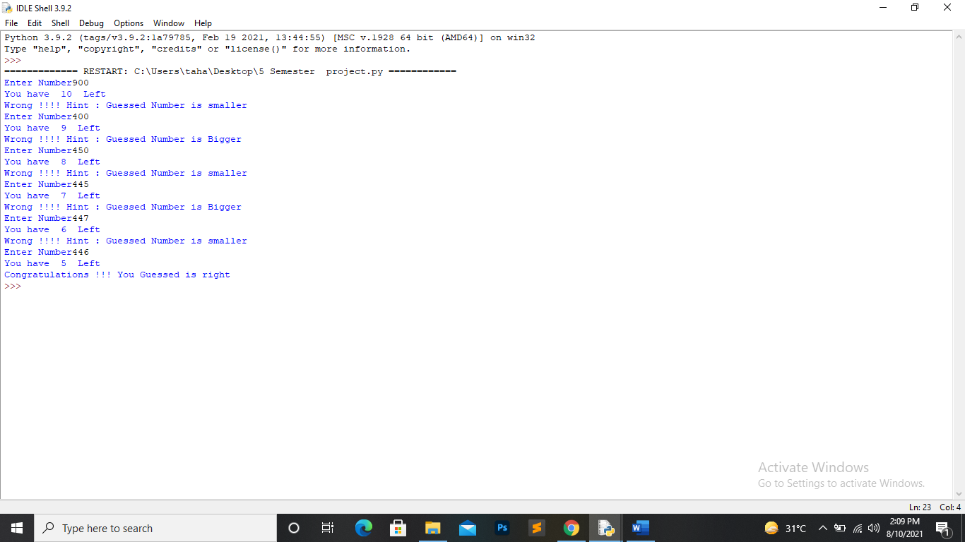
Program INTERFACE
